**Year 10 Physics Investigation #2 Acceleration**

*Based on Activity2 Pg 268 Pearson Science 10*

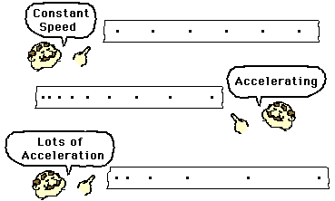

*Your task is to determine the relationship between acceleration of a toy car/trolley and the angle of the ramp it travels down.*

Your group will choose two or **three different** angles to run your toy car/trolley down. You will use ticker tape to measure the acceleration down each ramp.

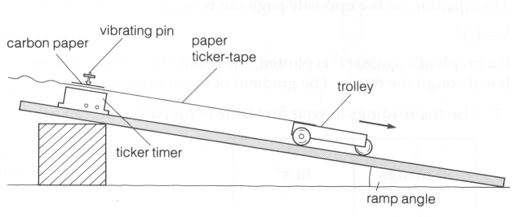

Your group will need to take care to control the length of the ramp and ensure that you label each of your ticker tapes carefully to avoid confusion.

The formula to work out average acceleration is:

[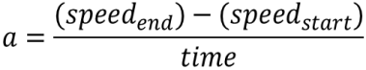](http://www.google.com.au/url?sa=i&rct=j&q=formula+acceleration&source=images&cd=&docid=n1BQvXMu3V1gnM&tbnid=tyy5e7co4fxZgM:&ved=0CAUQjRw&url=http://www.etorgerson.net/WebPages/ScienceUnits/A04_Acceleration.html&ei=ivH1UbrJMIiPkwW0pYD4Bg&psig=AFQjCNGKaO8mY3zS4cauOZdzzpsrQErjaw&ust=1375159034805046) or $a=\frac{v-u}{t}$

Remember that your initial speed is 0m/s as you were holding the car still at the top of the ramp. You will select 10 dots near the end of your tape to work out end speed.

There will need to be more than one trial for each angle. You will need to work out the average acceleration for each trial and produce an average acceleration for each ramp angle. Your calculations should be set out clearly showing all working

Please read the marking key carefully as it outlines what is required in each section of your investigation.

Name:_____________________________

|  |  |  |  |
| --- | --- | --- | --- |
|  | **Details** | **Available**  **mark** | **Your**  **mark** |
| **Title** | Descriptive NOT Physics Investigation | 1 |  |
| **Aim** | Why are you doing this experiment? What do you want to find out? | 1 |  |
| **Hypothesis** | Correctly worded  Includes dependent and independent variables | 2 |  |
| **Independent Variable** | The variable I change (I for independent). When you change the independent variable the variable you are measuring (the dependent variable) will probably change too. | 1 |  |
| **Dependent Variable** | The variable you are measuring. Any change in this variable depends on what you do to the independent variable. | 1 |  |
| **Controlled Variables** | All the things you keep the same to make it a fair test. You should usually list at least three. | 2 |  |
| **Materials** | Complete  Listed  Detail eg 25g of salt or 3 x 250ml beakers | 2 |  |
| **Method** | * Step by step with numbers * Written in past tense * Complete * Labelled Diagrams or photos – referred to in text * Explain how reliable results are achieved - trials/replicates, how variables are controlled | 1  1  1  2  3 |  |
| **Calculations** | Use the correct setting out and show all working.  Final speed for each tape, acceleration for each tape, average acceleration for each ramp angle | 6 |  |
| **Results** | Table - showing average acceleration for each ramp angle – neat and clear with units | 3 |  |
| **Graph** | Includes Title, labels on each axis, correct units, regular spaced, legend for each graph. Use a ruler, do it in pencil and make it neat | 5 |  |
| **Discussion** | * Errors * Effects of errors on results * Solutions | 1  1  1 |  |
| **Conclusion** | * What did the results show? * Use figures from your results * Does this support your hypothesis? * Scientific reasons – YOU NEED TO DO SOME RESEARCH FOR THIS PART | 1  1  1  3 |  |
| **References** | * As shown in student diary | 2 |  |
| **Presentation** | * Neat * Correct use of subtitles * In correct order * If typed, 12 font 1.5 spacing * All diagrams referred to in text. | 2 |  |
| **Total mark** | | **45** |  |